# 

# ARPAN ADHIKARY

Phone No. – (+91) 9038160496

E-Mail – [arpanadhikary@its.edu.in](mailto:arpanadhikary@its.edu.in)

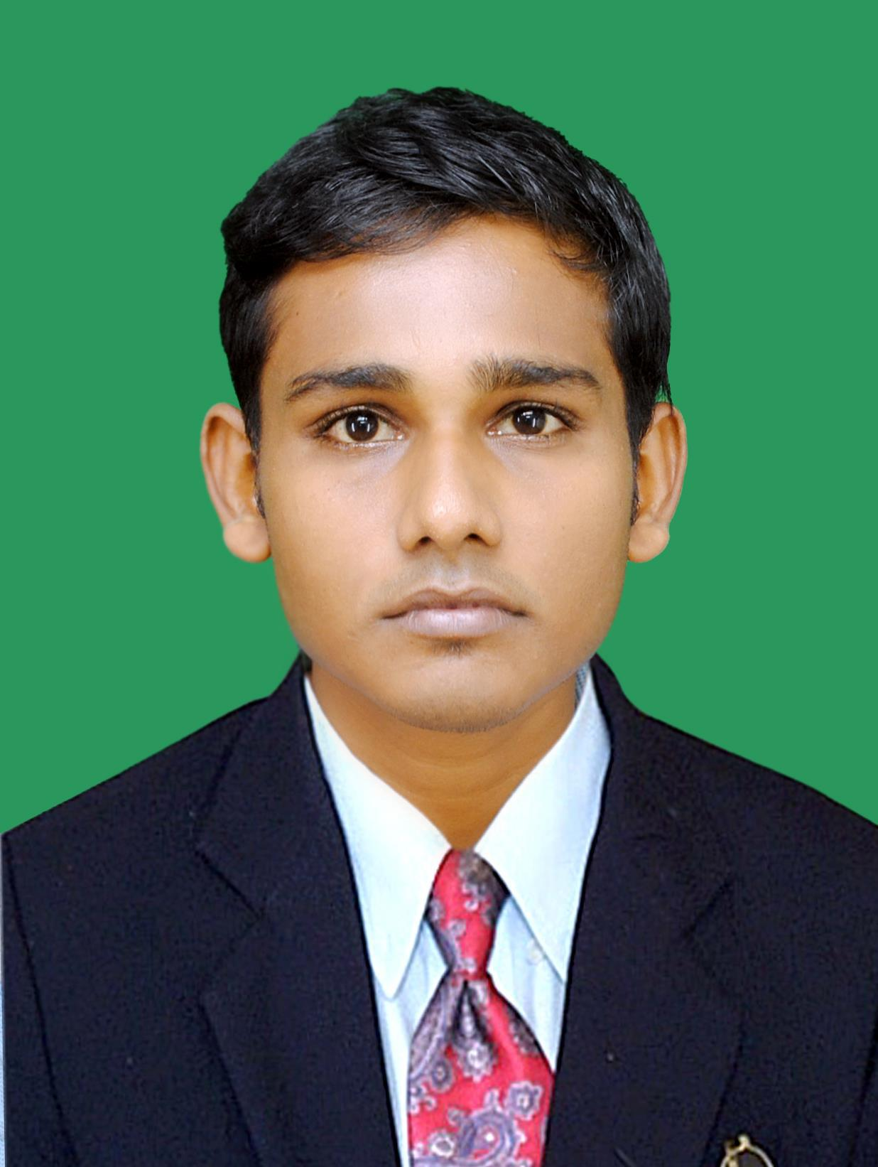

# 

**CAREER OBJECTIVE:-**

To be part of an organization where I can apply my knowledge, collaboration, interpersonal skill and efficiently to achieve the organization goal.

**KEY SKILL:-**

* Customer Relations.
* Customer Handling.
* Self confident & Optimistic.
* Customer service.
* Persuader

**EXPERIENCE**

**Alstrong Enterprises India Pvt. Ltd**

Tenure: 1st April,2016 to Present

Position:- Executive sales and Marketing

Location:- Kolkata

Responsibilities:

* Managing the entire sales & distribution network for the Howrah & Kolkata region.
* Managing, Coordinating, guiding sales team to execute business plans.
* Creation of a strong network with architects / contractors / consultants / builders.
* Introducing different brand promotion activities to increase the brand visibility in the region.
* Creation & managing of relationship with different channel partners in the region.

**Cryoviva Biotech Private Limited.**

**Tenure: -** 11th March, 2015 to 22 March 2016.

**Position: -** Sales Trainee.

**Location: -** Kolkata.

**Responsibilities: -**

* Responsible for Identifying potential customer base and convince them to subscribe to  
  the concept of Stem Cells Banking for self and family members.
* Responsible for building healthy relationships with gynecologists/doctors/customers  
  and generate primary leads
* Responsible for explaining the concept via home presentations to potential and  
  existing customers.
* Responsible to complete full cycle of client absorption into the system (i.e. Enrollment,  
  Payment follow ups and Collection.
* Actively involved in different marketing activities to enhance the business;

**Summer internship:-**

**At ‘Bank of Baroda’** Project done on the topic **‘A study on customer satisfaction with special reference to Bank of Baroda’.**

**Key Learning: -**

* Meeting the concerned person and proposing the retail products.
* Handling queries of customer about the retail products.
* Approaching the prospective customers through seeking an appointment.
* Maintain and develop customer relationships, new business, and periodic visit to existing customers.

**Internship Time Period: -** 21th April to 21th June, 2014

**Location: -** Retail Loan Factory(B.O.B),NoidaSec-29,Ganga shoping complex.

**SAVI LEATHERS(**A Government Recognised Export House**):-**

**Tenure: -**2nd Jan to 2nd March, 2015.

**Position: -** Management Trainee.

**Location: -** Noida,A-24,Sec- 57,U.P,India.

**Key Learning:-**

* Communicating with target audiences and managing customer relationships.
* Overseeing production processes.
* How to package of a final product.

**BIG BAZAAR**

Place : - E.D.M, Delhi

Project Title: Customer Services and Sales.

Tenure: - One Week

**Brief : -** to promote the sale of goods, especially by their presentation at Big Bazaar.

**Key Learning:-**

* Studied product awareness.
* Studied the feature of the product & Part of the sales team as a member.
* Help to achieve the targets for the mentioned time period.
* Responsible to create the brand awareness and the product awareness.

**PROFESSIONAL QUALIFICATION:-**

|  |  |  |  |
| --- | --- | --- | --- |
| **EXAMINATIONonal interests:shments:** | **BOARD/ UNIVERSITY** | **%/CGPA** | **YEAR OF PASSING** |
| **PGDM [Marketing (Major) & IB (Minor)]** | Institute of Technology and Science, Ghaziabad | 5.87 | 2015 |
| **Graduation [B.T.H.S]** | Utkal University of Culture | 74.76% | 2012 |
| **Higher Secondary (12th)** | West Bengal Council of Higher Secondary Education | 75.44% | 2009 |
| **Secondary (10th)** | West Bengal Board of Secondary Education | 71.12% | 2007 |

|  |  |
| --- | --- |
|  |  |

**PERSONAL INFORMATION:-**

**Date of Birth** 25-05-1990

**Language Known** English, Hindi, Bengali, Oriya

**Permanent Address** Village-Dabadari,Post-Lowada,P.S-Debra,Dist-Paschim Medinipur**,**

**DECLARATION:-**

**I hereby declare that the details provided by me in this resume are correct and I have knowingly not omitted/ misrepresented any information. I am aware that the company can use this data for verification purposes and any material inconsistency identified between the details shared above versus actual information would have a bearing on my employment, based upon company policies.**

Date: Thursday, June 1, 2017

Place: Kolkata **ARPAN ADHIKARY**